**GenAI BOT**

**Bot took just 6 seconds to generate automated UI and API test cases in 6 different automation frameworks**

**1.Generate automated UI tests**

**1.1 Generate automated UI test cases in Java selenium after reading requirements from Jira**

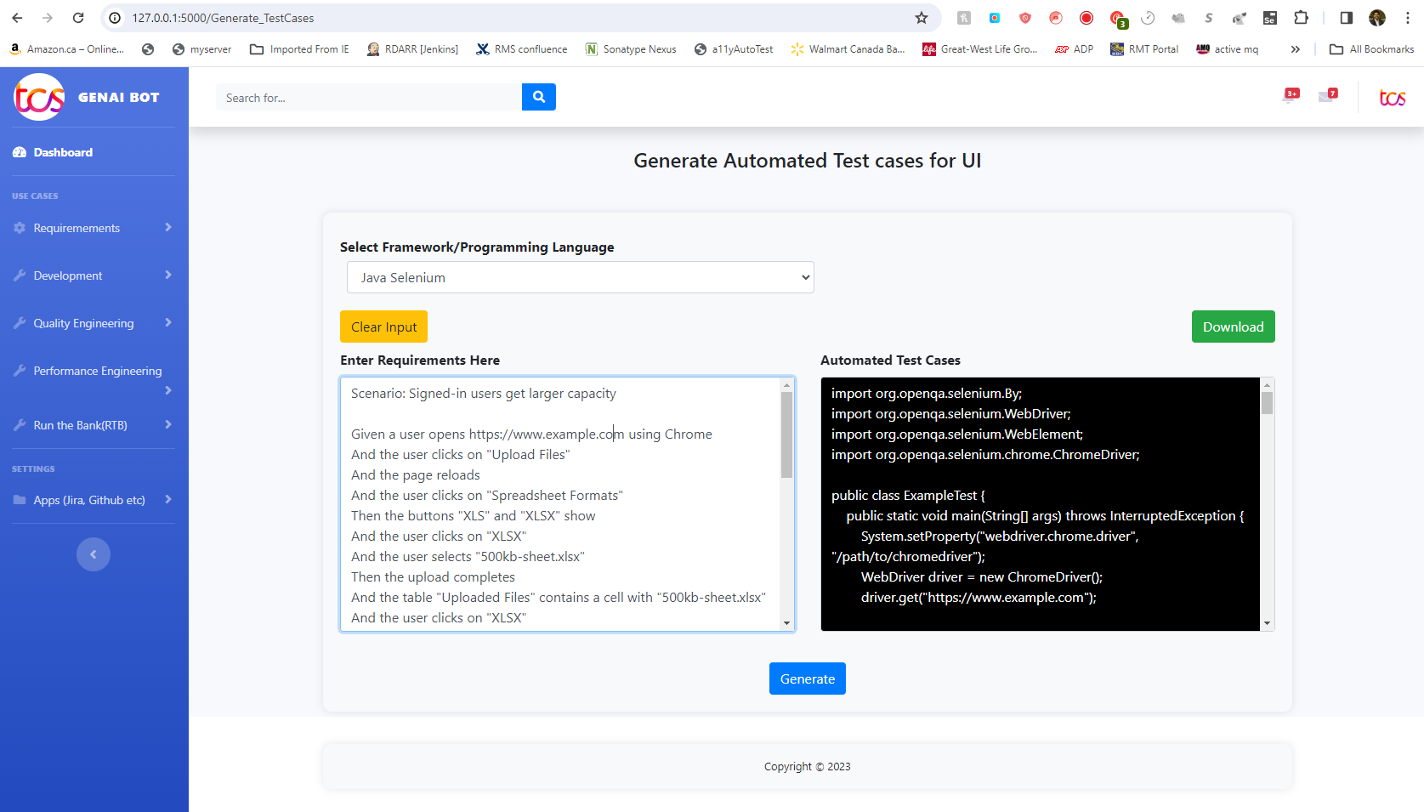

**1.2 Generate automated UI test cases in Robot Framework after reading requirements from Jira**

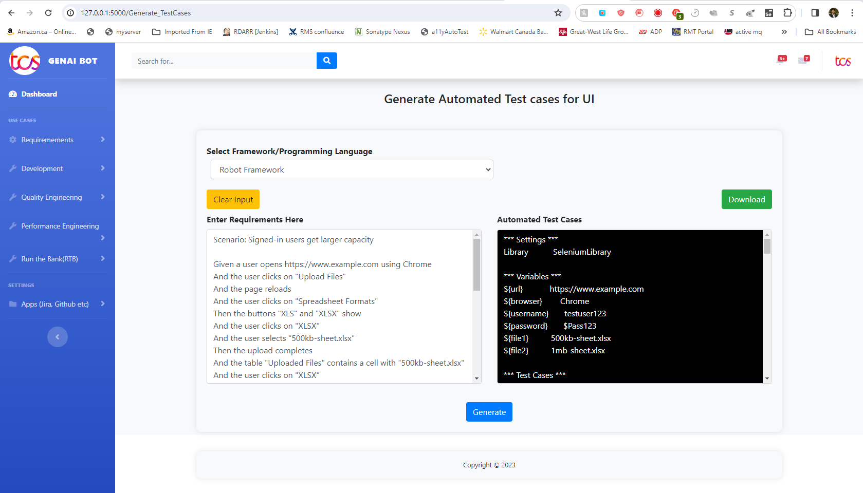

**1.3 Generate automated UI test cases in Python Selenium after reading requirements from Jira**

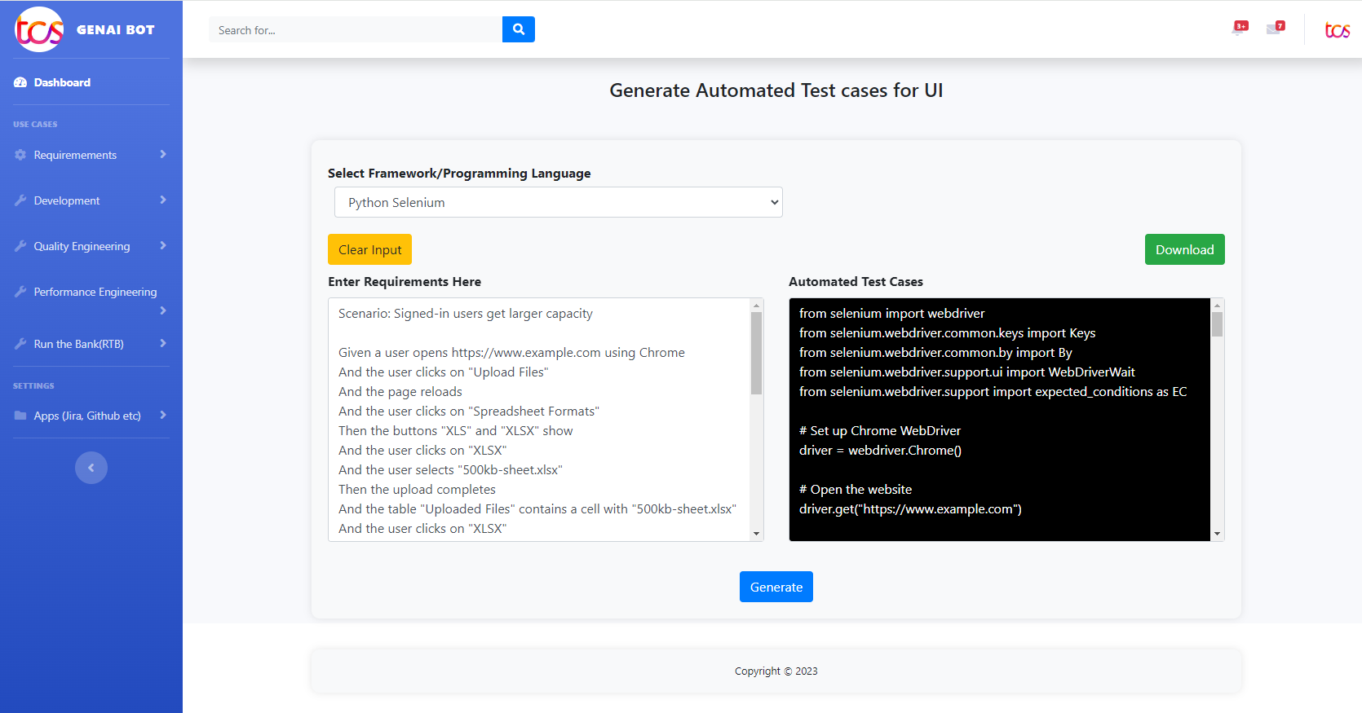

**2.Generate automated API tests**

**2.1.Generate automated API test cases in Rest Assured after reading requirements from Jira**

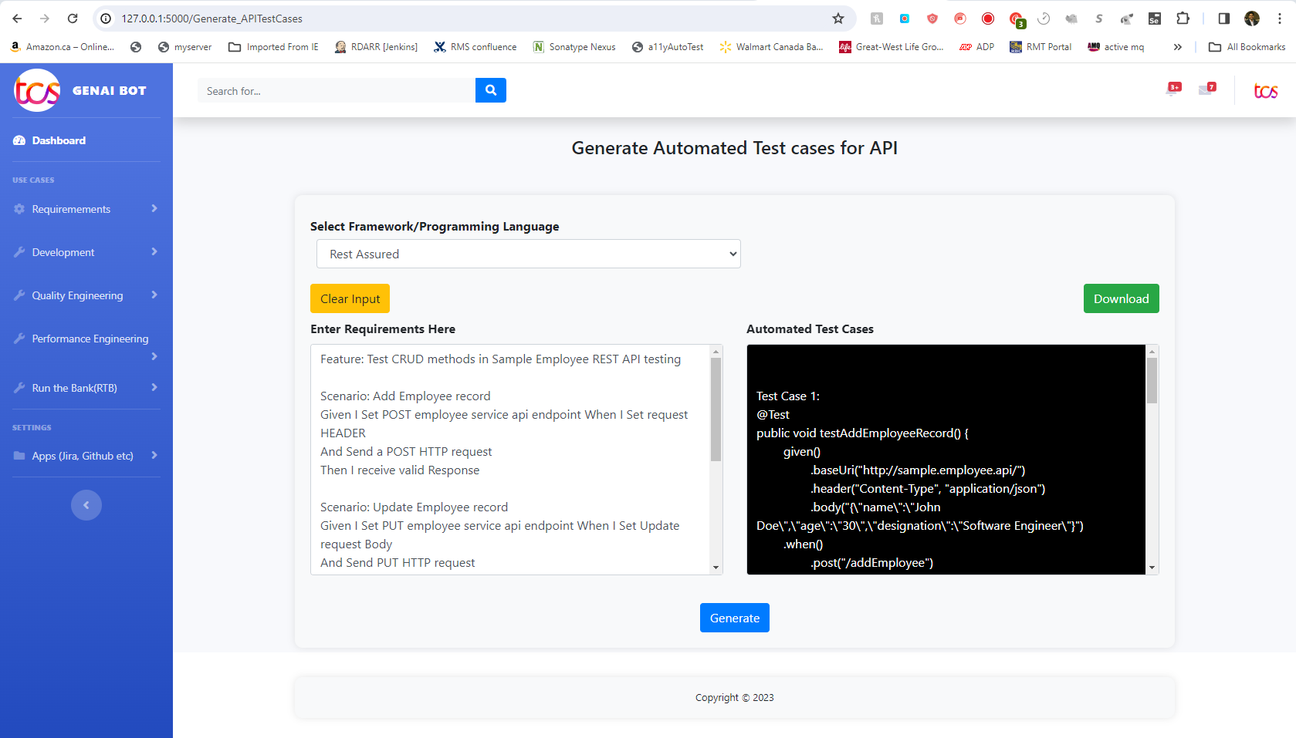

**2.2.Generate automated API test cases in Karate Framework after reading requirements from Jira**

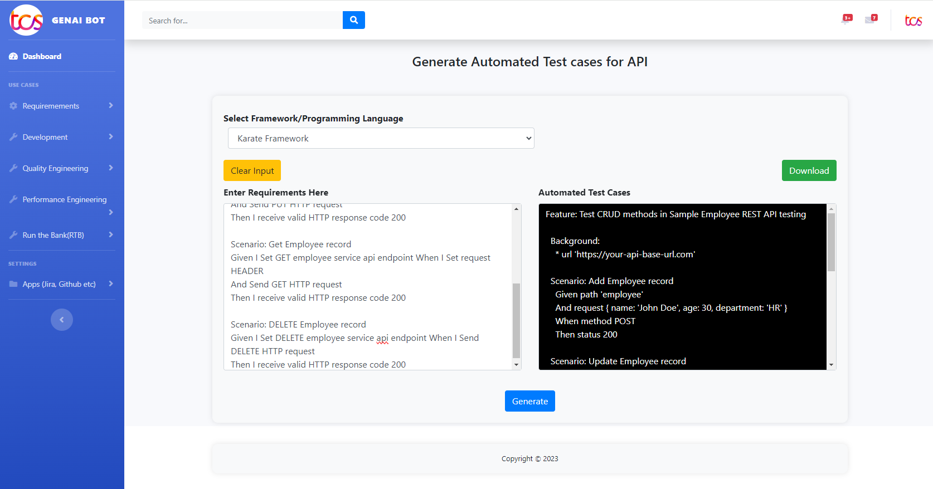

**2.3.Generate automated API test cases in Karate Framework after reading requirements from Jira**

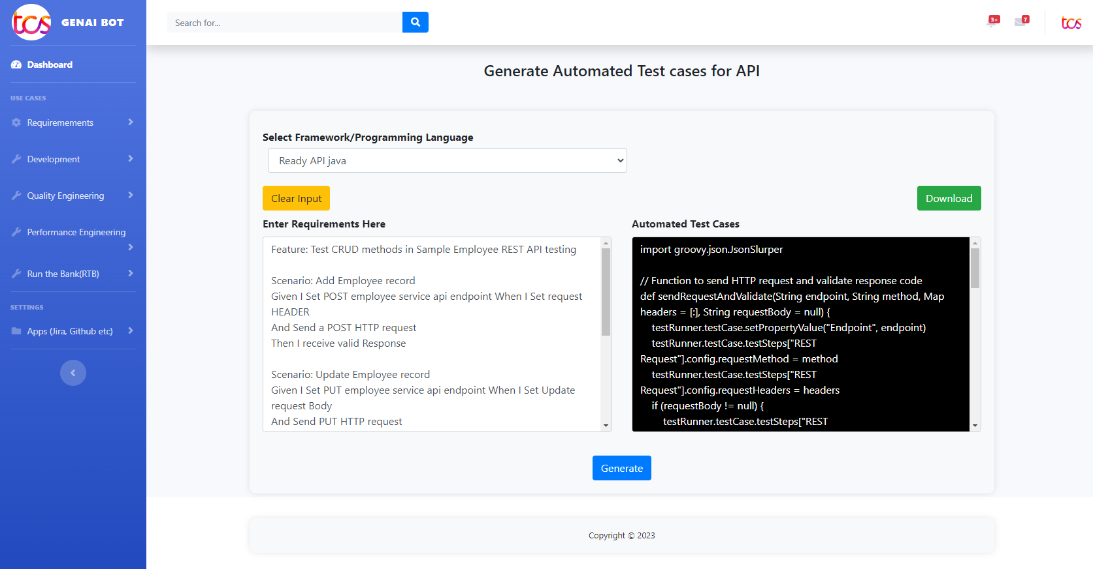

**3.Generate automated API tests and test data after reading swagger specification**

**3.1.Generate automated API test cases along with test data in rest Assured after reading swagger specification**

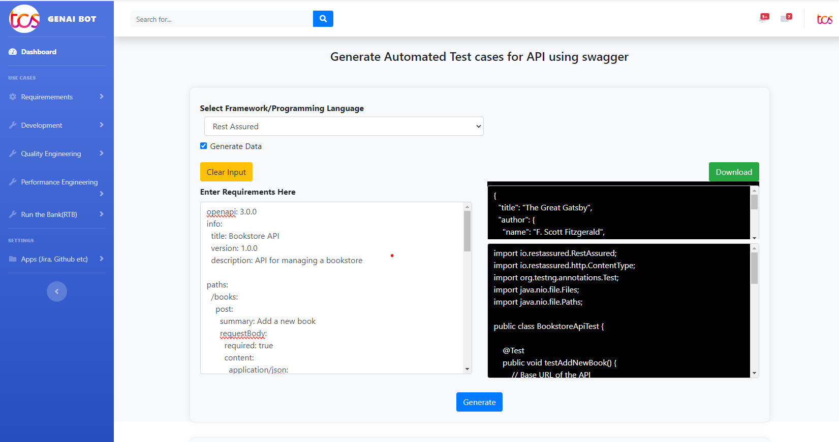

**3.2.Generate automated API test cases along with test data in Karate framework after reading swagger specification**

